General Background on the Biology of the Disease
When you eat, your body breaks down the sugars and starches from food into glucose. The body uses insulin to convert glucose into energy to fuel the cell in your body. When your body doesn’t produce enough insulin, you may develop diabetes. In Type 1 diabetes, the body does not produce insulin. This type of diabetes is hereditary and is usually diagnosed in children and young adults and was previously known as juvenile diabetes. Only 5% of the people with diabetes have this type of the disease. With the help of insulin therapy and other treatments, people with this disease can learn to manage their condition and live long, healthy, happy lives.
Medical Innovations that have Made Living with Diabetes Easier:
- New blood glucose meters are computerized, and quick and easy to use
- Monitoring and Treatment of Disease:
  - A1C Blood Test:
    - The A1C test measures your average blood glucose control for the past 2 to 3 months.
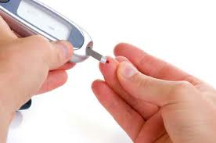
    - It is determined by measuring the percentage of glycated hemoglobin, or HbA1c, in the blood.
    - Check your A1C twice year at a minimum, or more frequently when necessary.
    - Blood sugar level between 100 and 125 mg/dL is considered prediabetes.
    - It does not replace daily self-testing of blood glucose.
References:
What is diabetes. (2012). Health Central. Retrieved from http://www.healthcentral.com/diabetes?ic=2300
Diabetes basics. (2012). American Diabetes Association. Retrieved from http://www.diabetes.org/
Nazario, B. (2011). A sample meal plan for diabetes. WebMD. Retrieved from http://diabetes.webmd.com/sample-meal-plan

By: Eslie Aguilar
10/05/2012
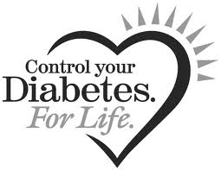
PBS A day Pm

Basic Recommendations For a Diabetic Diet
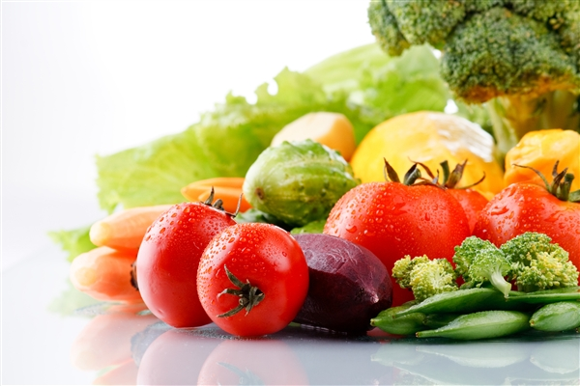
Fast food, soda, and white bread are all high in calories and low in nutritional value. If you eat more of this kind of food than fruits, vegetables, and lean meat, you may be more likely to develop diabetes.
Example Menu For A Day:
- Breakfast: (360 cal., 52.5 g carbs)
  - 1 slice toasted whole wheat bread with 1 tsp margarine
  - ¼ cup egg substitute or cottage cheese
  - ½ cup oatmeal
  - ½ cup skim milk
  - ½ small banana
- Lunch: (535 cal., 75 g carbs.)
  - 1 cup vegetable soup with 4-6 crackers
  - 1 turkey sandwich (2 slices whole wheat bread, 1 oz turkey and 1 oz low-fat cheese, 1 tsp mayo)
  - 1 small apple
- Dinner: (635 cal.., 65 g carbs)
  - 4 oz broiled chicken breast with basil and oregano sprinkled on top
  - 2/3 cup cooked brown rice
  - ½ cup cooked carrots
  - 1 small whole grain dinner roll with 1 tsp margarine
  - Tossed salad with 2 tbsp low-fat salad dressing
  - 4 unsweetened canned apricot halves or 1 small slice of angel food cake
- Snack: (each has 60 cal. or 15 g carbs. Pick 2/day)
  - 16 fat-free tortilla chips with salsa
  - ½ cup artificially sweetened chocolate pudding
  - 1 oz string cheese plus 1 small piece of fruit
  - 3 cups light popcorn
See a nutritionist or dietician for the right diet plan specialized for your needs.
Keep Diabetes in Control by Staying Fit:
- Exercise: if you don’t get more than 30min of exercise three times a week, you increase your risk of getting diabetes.
Lifestyle: changing your eating and exercise habits to prevent diabetes will make you healthier overall. Walk, ride a bike, or swim three times a week. Eat a diet that includes more fruits and vegetables than chips and cookies. Eat lots of fiber and avoid white bread and rice. Losing even 20-35 pounds can also prevent diabetes.

Inspirational Quotes From the Perspective of a Diabetic:
“Let your food be your medicine, and let your medicine be your food.”—Hippocrates
“You have to be twice as good to be good—don’t fight it, figure out how to be that good and do it.”—Melcan McCulley (Diabetic Patient’s father)

