Structure and Function of Cholesterol:
Structure:
Cholesterol is a soft, waxy compound that circulates in the bloodstream. When formed, these compounds attach themselves to two unique types of carrier proteins, HDL (high-density lipoproteins) and LDL (low-density lipoproteins).
Function-LDL: Cholesterol that is attached to LDL proteins (primary carriers of cholesterol) has a negative function within the body. These cholesterol molecules attach themselves to the walls of the blood vessels and arteries, causing them to narrow. Eventually, this narrowing of the arterial pathways can cause a heart attack.
Function-HDL: Cholesterol that is attached to HDL proteins has a beneficial function within the body. HDL cholesterol molecules are able to attach themselves to harmful LDL molecules and carry them off to the liver where they are broken down and removed from the body.
How Does Intake of Unsaturated, Saturated, and Trans Fats Affect Cholesterol Levels and overall Health?

- Limit total fat intake to less than 25–35 percent of your total calories each day;
- Limit saturated fat intake to less than 7 percent of total daily calories;
- Limit trans fat intake to less than 1 percent of total daily calories;
- The remaining fat should come from sources of monounsaturated and polyunsaturated fats such as unsalted nuts and seeds, fish (especially oily fish, such as salmon, trout and herring, at least twice per week) and vegetable oils; and
- Limit cholesterol intake to less than 300 mg per day, for most people. If you have coronary heart disease or your LDL cholesterol level is 100 mg/dL or greater, limit your cholesterol intake to less than 200 milligrams a day.
References:
http://www.heart.org/HEARTORG/Conditions/Cholesterol/Cholesterol_UCM_001089_SubHomePage.jsp

What Is Cholesterol?
Eslie aguilar
PBS

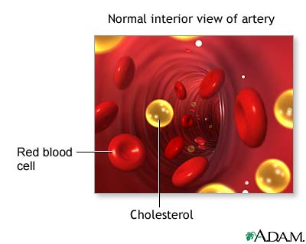
How Do LDL and HDL Differ Structurally and Functionally?
Structure
- All types of lipoproteins contain both lipids and proteins.
- Approximately 50% of the weight of an LDL particle is cholesterol and only 25% is protein.
- HDL particles consist of 20% cholesterol by weight and 50% protein (protein is more dense than fat, hence the names)
- LDL particles contain proteins called B-100 proteins
- HDL particles contain mostly A-I and A-II proteins (type of protein is significant because it determines the function of lipoprotein particle)
Function
- LDLs bring cholesterol to cells and can cause cholesterol buildup within arteries (buildup can lead to arterial blockage and an increased risk for heart disease and stroke)
- HDLs (carry 1/3 of total cholesterol) benefit health because they carry cholesterol away from the heart and other organs and deliver it back to the liver, where it is passed from the body.
Why Do Doctors Monitor the Concentrations of LDL and HDL Associated with the Risk for Heart Disease and Associated Disorders?
- Doctors ensure that there is not too much cholesterol building up in arteries (cholesterol is insoluble in bloodstream).
- Doctors monitor HDL level because according to the American Heart Association, HDL levels greater than 40 mg/dL reduce the risk of heart disease.
- Doctors monitor LDL levels because too much can put a patient at risk of heart attack or stroke.
What other Molecules in a Patient’s Blood Are Monitored along with LDL and HDL?
When getting your cholesterol checked, a lipid profile is ordered. This tells you total cholesterol, HDL, LDL, and triglycerides.
What Do the Results of a Cholesterol Test Mean?
Guidelines
Total Cholesterol Level | How Do Patients Interpret each Value? Desirable, Borderline,High | What Can Patients Do to Change the Levels of LDL and HDL in their Blood?
<200 | Desirable | None
>200 but < 240  >2 risk factors | Borderline | Diet and repeat  in 3 to 4 months
>240  LDL > 130 but <160  <2 risk factors | Borderline | Diet and repeat  in 3 to 4 months
>240  LDL > 130 known  coronary artery disease | High | Diet and medication  follow closely
>240  LDL > 130  known diabetes | High | Diet and medication  follow closely
>240  LDL > 160 two or  more risk factors | High | Diet and medication  follow closely
>240  LDL > 190 with or  without risk factors | High | Diet and medication  follow closely

